tips forum 2017
INDUSTRIALISATION AND SUSTAINABLE GROWTH

Towards labour absorptive, low-carbon economic development: identifying interventions for the reduction of greenhouse gas emissions in key agricultural value chains in the Western Cape

June 2017

Authors: Pieter Frederik Janse van Vuuren, Catherine Pineo,
Lauren Basson & Usisipho Gogela

Paper presented at the TIPS Annual Forum 2017
The Annual Forum 2017 is being hosted by Trade & Industrial Policy Strategies (TIPS) in partnership with the South African Research Chair in Industrial Development, based at the University of Johannesburg, and in association with the Green Economy Coalition (GEC). It is supported by the European Union and the Department of Trade and Industry.
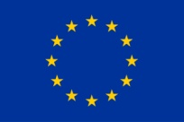

Abstract
Agriculture and agri-processing are significant in terms of GDP contribution, are highly labour absorptive and can make a significant contribution to household income in rural and marginal communities. Agricultural value chains are thus a key focus area for national and provincial economic growth. Yet, these value chains are a significant contributor to the carbon intensity of the economy, and particularly so in the case of the Western Cape. To enable a transition to a low-carbon pro-employment development path, it is thus necessary to identify targeted interventions within these sectors. This paper presents approaches to identifying the most carbon intense sectors of the economy at a sub-national level, and to identify high impact greenhouse gas (GHG) reduction interventions to reduce the carbon intensity of these sectors.
The carbon intensity of the Western Cape economy was assessed using a macro-economic analysis. The food value chain was identified as a key source of non-energy GHG emissions. The GHG emissions for the agricultural sector were then further analysed by considering key agricultural sub-sectors in the Western Cape, namely: wine, fruit, grain and livestock. Life cycle-based analysis of GHG emissions within these sub-sectors was then used to identify key emissions “hotspots” which were used to inform key areas of intervention to reduce the sector’s GHG emissions, while simultaneously supporting local economic development.
Four key opportunities were identified, namely: (a) solar heat for agri-processing, (b) solar photovoltaics (PV) on packhouses, (c) solar pumps and variable speed drives for irrigation, and (d) biogas from agri-processing wastes and residues. The business cases for these opportunities were examined to encourage sustainable, profitable development. This paper presents the methodology used, key results obtained and general insights gained to promote a transition to low-carbon, sustainable production in the labour absorptive agriculture and agri-processing sectors.

About the authors
The authors are members of a project team working in the Bioeconomy Programme at GreenCape, the sector development agency for the green economy in the Western Cape. The team does strategic studies on resource productivity for the Western Cape Government and provides technical support and analysis that feeds into the organisation’s annual market intelligence reports that aim to stimulate investment in the green economy (available from: www.greencape.co.za/market-intelligence).
Lauren Basson is GreenCape’s Manager: Technical and Knowledge. In this capacity she provides strategic and technical support to GreenCape’s energy, water, waste and agriculture programmes, and co-ordinates their knowledge generating activities. In addition, Lauren’s role is to broker links to knowledge and innovation institutions to support GreenCape activities and those of its member companies. Lauren holds BSc and MSc degrees in Chemical Engineering from the University of Cape Town, South Africa and a PhD in Chemical Engineering from the University of Sydney, Australia. Prior to joining GreenCape in 2013, Lauren worked industry and academia in South Africa, Australia and the United Kingdom. Lauren was the Project Manager for the Regional Resource Flow Model (2013/14-14/2015), Resource Productivity (2015/16) and Bioenergy and Product Diversification (2016/17) projects that form the foundation for this paper.
Pieter Frederik Janse van Vuuren is an Economic Analyst providing economic support to a number of projects at GreenCape. Pieter holds a Master’s degree in Economics from Stellenbosch University. Pieter was an analyst on the Regional Resource Flow Model (2013/14-14/2015), Resource Productivity (2015/16) and Bioenergy and Product Diversification (2016/17) projects.
Cathy Pineo hold a Masters degree in Molecular and Cell Biology from the University of Cape Town. Through her work at GreenCape Cathy has developed an in-depth understanding of the close-loop paradigm and experience in the application of the concepts and principles of the Circular Economy. She joined GreenCape's Western Cape Industrial Symbiosis Programme (WISP) in 2013 and facilitated the exchange of unused resources between companies i.e. turning waste into secondary materials, rather than being lost to landfill.
Further to this, Cathy’s expertise at GreenCape has extended into the bioeconomy and agricultural value chains. From 2014, she provided both analytical and strategic expertise on resource-based projects under the GreenCape Bioeconomy Programme. Since 2016, she has been managing the GreenCape Agriculture Sector Desk, run in collaboration with the Western Cape Department of Agriculture. With the help of her team, Cathy is championing the “greening” of agricultural value chains. This will be key in terms of supporting the development of sustainable and competitive agricultural value chains in the Western Cape and beyond.
Usisipho Gogela joined GreenCape in 2016 and is currently employed as a Bioenergy Analyst. He provides support to external bioenergy stakeholders, as well as contributes to GreenCape’s internal knowledge base. Usisipho was an anaylst on the Bioenergy and Product Diversification (2016/17) project, which informed some of the content in this paper. He holds a BSc in Chemical Engineering from the University of Cape Town.

Contents
1. Introduction 6
2. Approach 6
2.1. Economic analysis 7
2.2. Resource needs of key agricultural sectors 8
2.2.1. Wine Sector 9
2.2.2. Fruit sector 11
2.2.3. Grain sector 12
2.2.4. Livestock and game sector 14
3. From focus areas to GHG reduction interventions 15
3.1. General drivers 15
3.2. Solar heat for agri-processing 16
3.2.1. Barriers 18
3.2.2. Drivers 18
3.3. Solar PV on packhouses 19
3.3.1. Barriers 20
3.3.2. Drivers 20
3.4. Solar pumps and variable speed drives for irrigation 20
3.5. Biogas 21
3.5.1. Business case for biogas 22
3.5.2. Factors influencing the financial viability of biogas projects in the Western Cape: 22
3.5.3. Key barriers influencing uptake of biogas projects in the Western Cape: 23
4. Conclusion 23
5. References 25

Abbreviations
AD | Anaerobic Digester
CCC | Confronting Climate Change
CO₂e | Carbon dioxide equivalent
Combud | Commercial Enterprise Budgets
DEDAT | Department of Economic Development and Tourism
EFOM | Energy Flow Optimization Model
GHG | greenhouse gas
LCA | Life Cycle Analysis
kW_{p} | Kilowatt peak
MARKAL | Market Allocation
MRIO | Multi-regional input output
MW_{p} | Megawatt peak
SAM | Social Accounting Matrix
SAWIS | South African Wine Industry Information & Systems
TIMES | The Integrated MARKAL-EFOM System

Introduction
As the sector development agency for the green economy in the Western Cape, GreenCape was commissioned by the Department of Economic Development and Tourism (DEDAT) to analyse the provincial economy for opportunities for improved resource efficiencies in order to improve businesses’ competitiveness and drive the development of the green economy. This work was initiated as the “Regional Resources Flow Model” project in 2013 which strategically analysed the provincial economy to identify possible resource constraints that may limit the competitiveness of key sectors. This paper presents how this project developed targeted GHG reduction strategies and identified specific interventions.
The project developed in three phases. The first phase highlighted the food value chain as a key generator of greenhouse gas (GHG) emissions, most notably non-energy emissions. The second phase of the project considered key areas of intervention, or hotspots, for GHG emissions reduction in key sectors. This analysis also considered the economic potential within these sectors. The third phase of the project identified and developed strategic interventions to enable GHG reduction along the food value-chain to address some of the GHG emissions hotspots identified in the second phase. This was done by working closely with industry to facilitate uptake of green (emission reduction) technologies given GreenCape’s goal to increase investment and job creation in the green economy.

Approach
The project used two complementary approaches. In the first phase, a top down economic analysis identified key economic sectors and an initial focus area (food value chains). The second phase undertook a more detailed bottom up analysis of sub-sectors (wine, fruit, grain & livestock) within the identified sector. These phases are illustrated in Figure 1.
Figure 1: Overview of the Regional Resource Flow Model project

The key results from these analyses are presented in turn below (Section 2.1 and 2.2). The third phase of the project entailed the identification and development of strategic interventions to address the hotspots identified in the second phase. The interventions are presented in the form of business cases to industry, to facilitated uptake, and are discussed in Section 3.

Economic analysis
The economic analysis made use of a provincial social accounting matrices (SAM) developed for the Development Bank of South Africa (2008), and included GHG emissions from a variety of sources. The analysis highlighted the food value chain as a key source of non-energy GHG emissions, as shown using Sankey diagrams in Figure 2 and Figure 3. In these figures, the emissions related to the trade between sectors are shown as a line. The thicker the line is, the stronger the relationship, i.e. the greater the amount of GHG emissions related to the economic activity between the two sectors. By considering Figure 2 and Figure 3 concurrently, it is clear that the agricultural sector is a key contributor of non-energy emissions. The non-energy emissions are related to land-use and land-use-change. This is supported by a range of literature including the report “Livestock’s Long Shadow” (Steinfeld, et al., 2006).
As an area of focus, the importance of the agricultural sector is also emphasised by a number of supporting criteria. It is the largest water user in South Africa. It is highly labour absorptive, especially of low-skilled labour and it is a key export sector. When considering the value of production, over 30% of Western Cape agriculture production is exported, with the Western Cape contributing more than 45% of South Africa’s total agricultural exports (Western Cape Government Provincial Treasury, 2013). Thus, the agricultural sector is clearly a significant contributor to the economy and key area for targeted intervention.

Figure 2: Energy emissions for Western Cape sectors (Janse van Vuuren, 2015a, p. 12)

Figure 3: Total GHG emissions for Western Cape sectors (Janse van Vuuren, 2015a, p. 13)

Resource needs of key agricultural sectors
The second phase of the project considered a more detailed analysis of the carbon intensity of agriculture. To consider which sub-sectors were the most significant, their relative sizes in terms of Rand value output were considered. This is shown in Figure 4 below.

Figure 4: Western Cape agricultural sector breakdown, based on Rand value output

As agricultural sub-sectors have vastly different farming practices, which will directly impact their carbon intensity, the analysis focused on four archetypical commodities or commodity groupings to make the analysis tractable. The commodities chosen were:
- Wine sub-sector
- Fruit sub-sector
- Grain sub-sector
- Livestock and game sub-sector
The importance of each sub-sectors is described in detail below in conjunction with an examination of the sector’s emission using life cycle-based analyses to identify GHG emissions hotspots. In life-cycle based analysis the environmental impacts associated with a product is considered along a product’s life from cradle (raw material extraction) to grave (disposal) or, simplistically, along its full value chain. The extent to which the full value chain for each sector could be analysed depended largely on available data; hence some differences in the scope of the analysis for the different sub-sectors (see below). The life cycle based analysis was used to highlight “hotspots” (i.e. primary sources of emissions) where targeted interventions would have the greatest impact.

Wine Sector
The wine sector is of significant importance as an export revenue earner, with 60% of South African wine being exported and South Africa producing 4% of the world’s wine (van Niekerk, 2014). The Western Cape is the main wine producing region in the country producing 95% of its wine (SAWIS, 2014).
The Western Cape wine’s carbon footprint was compared to the carbon footprint of wine internationally (see Figure 5). This was based on Confronting Climate Change’s (2014a) carbon footprint report for the wine sector in conjunction with an international review of carbon footprints of wine undertaken by Rugani et al. (2013).
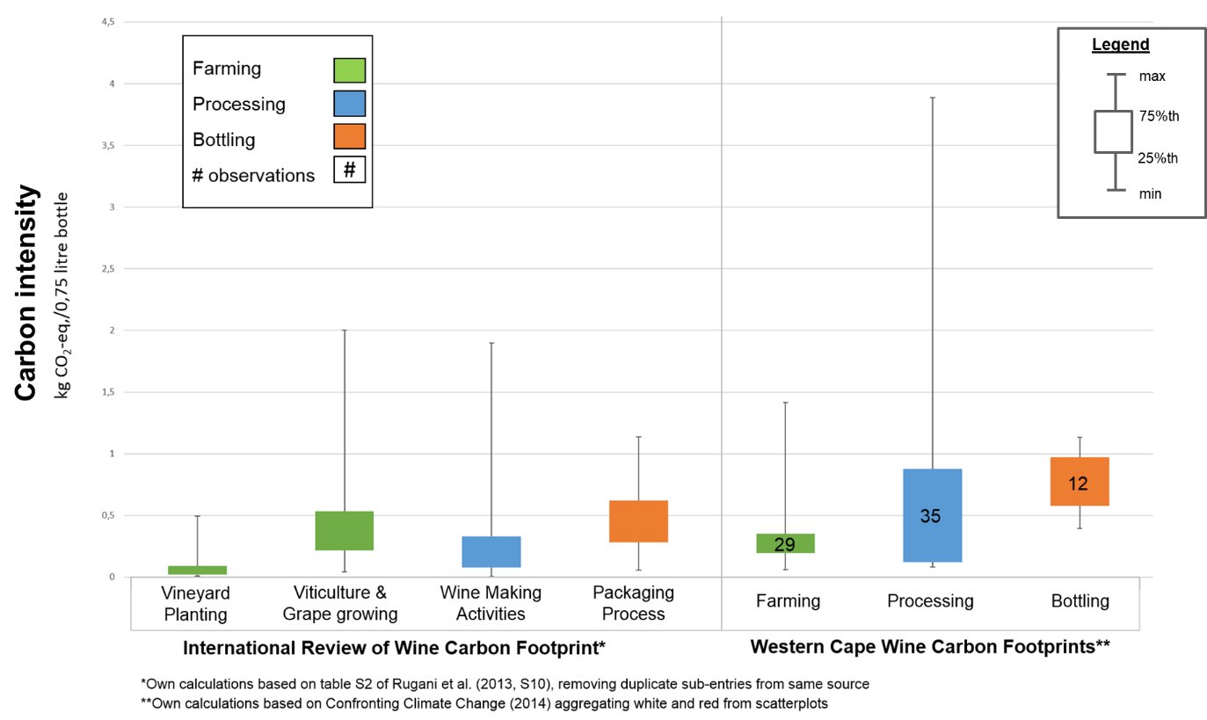
Figure 5: Comparison of International and Western Cape Carbon Footprints of wine

The key result was that while overall South African wine may be more carbon intense than wines internationally, this seems to be driven strongly by emissions that are not related to the farming components as shown in Figure 5. The production of wine grapes on South African farms was actually within the lower range of international GHG emissions for the farm stage of the value chain. The poor performance of South Africa at the processing stage is due to South Africa’s very carbon-intense energy mix, as a large share of South Africa’s energy supplied through the national grid is coal-based. This analysis highlighted processing as a key area for targeted GHG emission reduction within wine, particularly for wine exports to countries who are increasingly concerned with the carbon intensity of products.

Fruit sector
As shown in Figure 6, the Western Cape makes up most of South Africa’s fruit sector, especially with respect to the pome and stone fruit sectors. The citrus fruit sector, while still significant in the Western Cape, has a large share of production further north in South Africa.
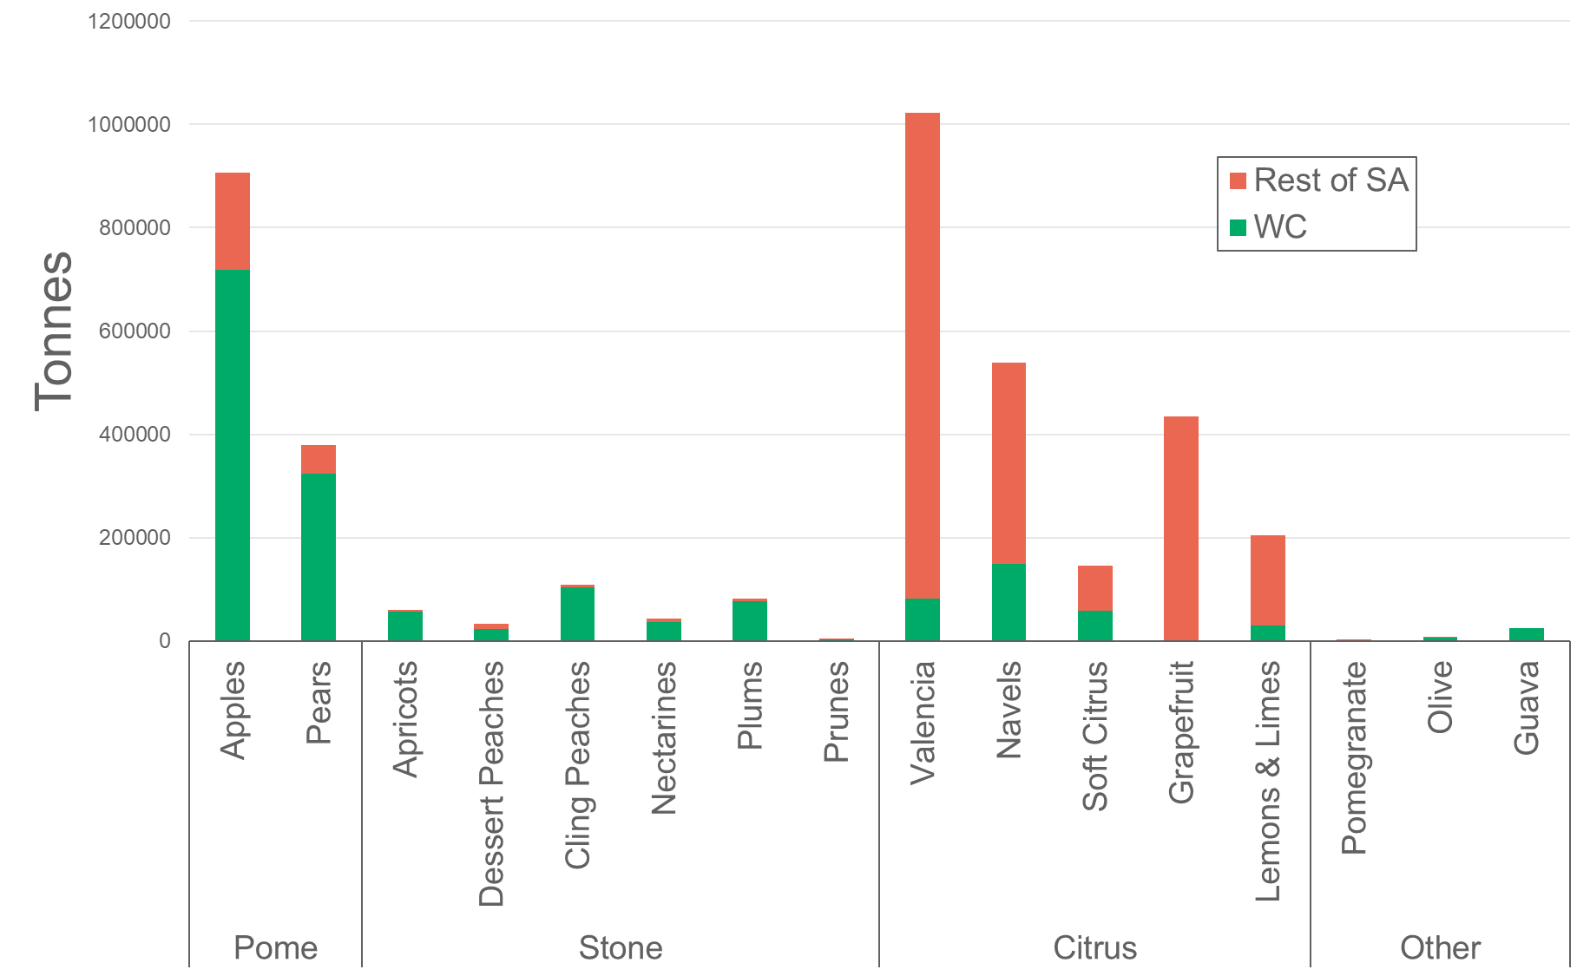
Figure 6: Fruit sector production South Africa and Western Cape 2013

For the fruit sector, similar to the wine sector, GHG emissions were considered based on the Confronting Climate Change carbon footprints (Confronting Climate Change, 2014b-f). For each of these fruit sectors, the GHG emissions were broken down to the different stages of production. The results for the pome fruit sector are illustrated in 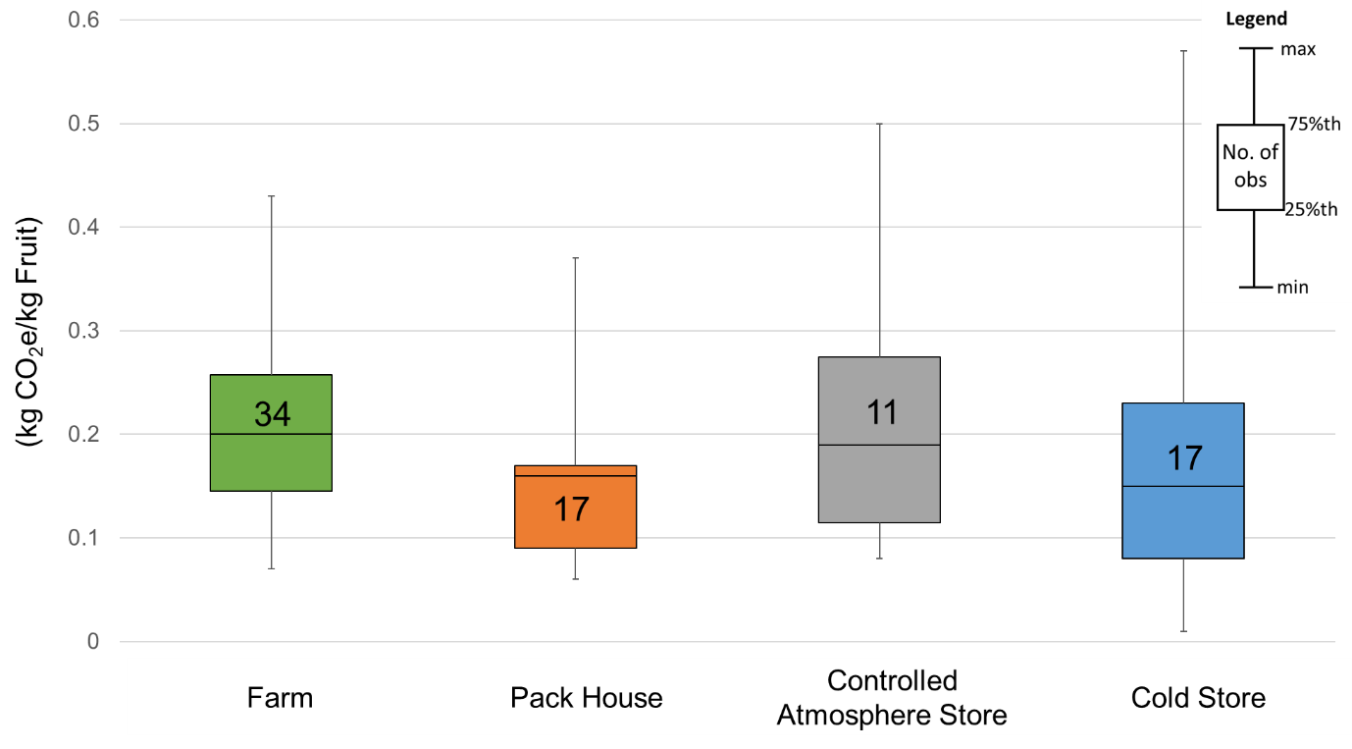
Figure 7, with additional results for citrus, pome and table grapes published in the full report (Janse van Vuuren, 2015c).
For both fruit and wine, the lack of information on nursery stages means that the carbon footprints were not completed in line with life cycle assessment (LCA) best practice principles for fruit. These principles require that 6 stages, namely nursery, establishment, low production years after establishment, full production years, low production year after full production years and dismantling, are considered (Cerutti, et al., 2015, pp. 368-369). This suggests that more informed decisions can be made if information for all these stages were made available for LCAs.

Figure 7: Box plots of carbon footprints of Western Cape pome fruit for 2013

The farm stage features more prominently in Figure 7 than in the wine sector, as there is less processing required for packaged fresh fruit relative to wine. It also shows that the farm level, with the most observations (34) has a relatively small range in comparison to the storage components (controlled atmosphere and cold store), indicating similar GHG emissions results from different farms. However, the controlled atmosphere storage and cold store stages’ wider ranges (with fewer observations), especially on the upper range, indicate that there are large GHG emission (and great variability) at this stage and it is possible to achieve lower emissions. This makes storage stages key areas to consider for strategies to decrease GHG emissions. When one considers that packing, cold store and controlled atmosphere storage can all occur at one site, the packhouse, the results indicate it as a key intervention area to influence the carbon intensity of fruit. Additionally, CCC (2014e, p. 12) highlighted that the carbon footprints of fruit are driven by the hardiness of the fruit. This is due to hardier fruit requiring less packaging and thus have a reduced carbon footprint related to packaging.
Thus, the packhouse is a clear area for intervention to reduce the GHG emissions from fruit, most notably pome fruit that utilises controlled atmosphere storage for long periods of time.

Grain sector
The grain sector analysis made use of the commercial enterprise budgets (Combuds) that the Western Cape Department of Agriculture prepares to help inform farmers and potential farmers of the financial feasibility of different crops. The budgets often include the physical quantities of the inputs, which make them a useful data source for life cycle analyses. This is especially true as the budgets are regionally differentiated and includes some crop rotations and tilling practices. Water footprints completed using CropWat were used to consider the water needs (CROPWAT, 2015). From the 34 wheat crops budgets, covering four districts and several production areas, four were chosen to highlight the key drivers of GHG emissions, specifically three dryland wheat production budgets (two budgets for farms using conventional production practices and one for a farm using minimum tillage practices) and one irrigated wheat budget.
These water footprints, together with the Combuds, were used to develop Life Cycle Assessments (LCAs) for wheat in the Western Cape. The wheat LCAs examined potential environmental impacts associated with wheat production, including climate change (measured in terms of GHG emissions), terrestrial acidification and freshwater eutrophication (Pineo, 2015a). The GHG emissions results from the four wheat LCAs have been extracted for this paper and are shown in Figure 8 and Figure 9.
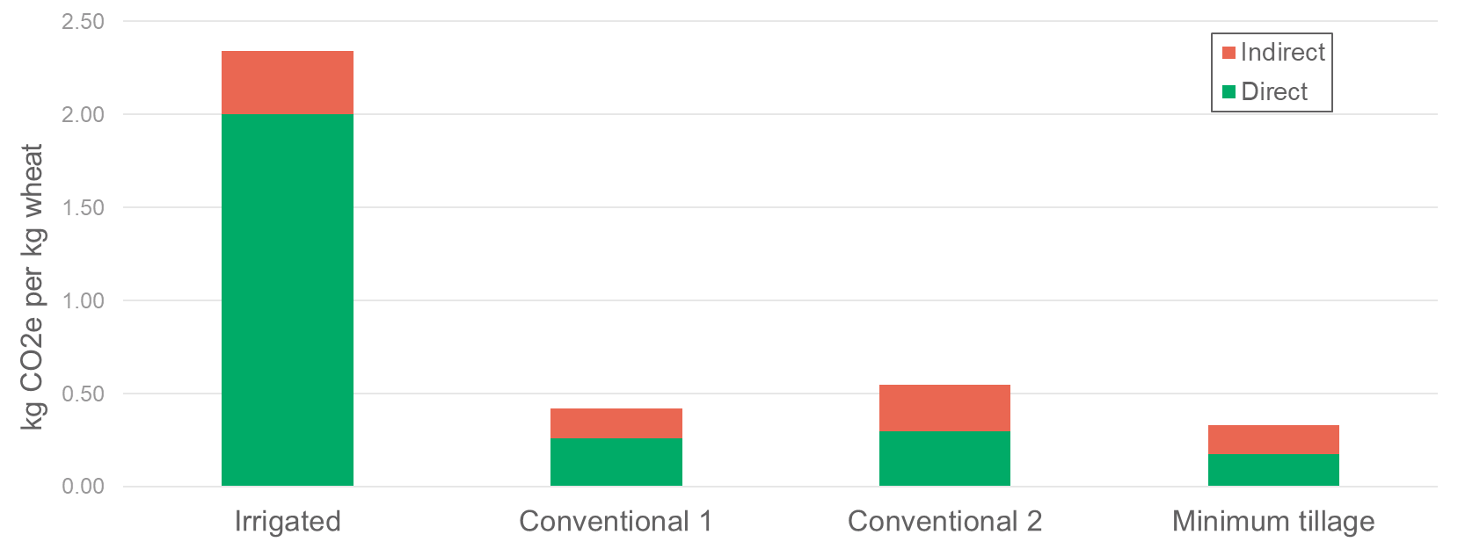
Figure 8: Indirect and direct contributions to GHG emissions of wheat production in the Western Cape for four different farming practices

The emisssions are broken into direct (or on-farm emissions) and indirect (or off-farm) emissions, highlighting that there are significant shares of the GHG emissions related to farming that occur off farm.
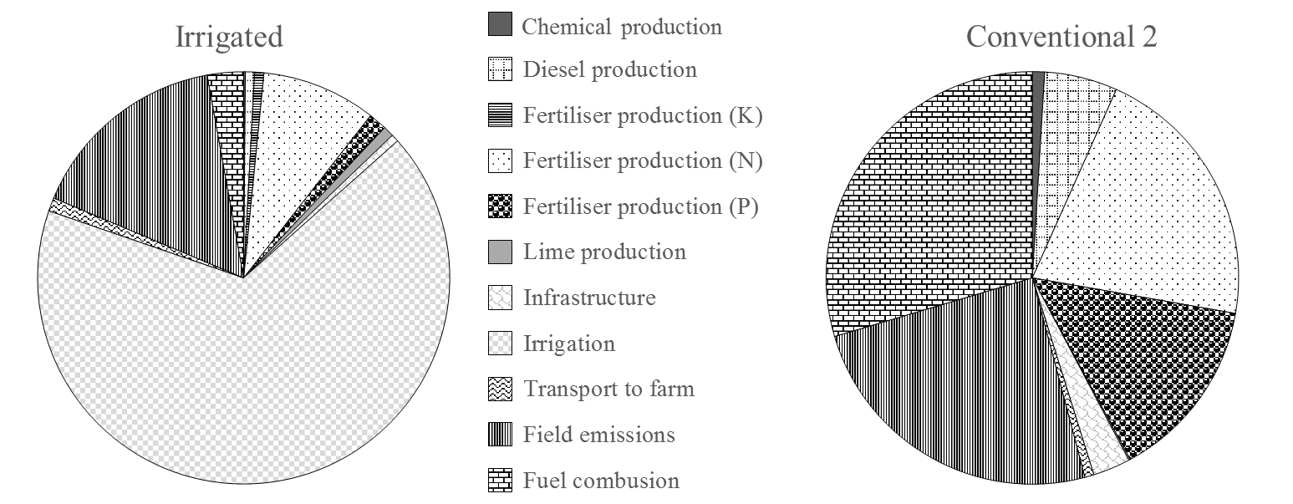
Figure 9: Breakdown of GHG emission sources for irrigated and conventional wheat farming practices

The results clearly showed that irrigated wheat is significantly more carbon intense and this is strongly driven by energy needs of irrigation. Additionally, field emissions and fuel combustion contribute a significant share of direct impacts, with indirect impact driven strongly by fertiliser (nitrogen, phosphorus and potassium) production.

Livestock and game sector
The livestock sector is under increasing public scrutiny since the launch of the UN report “Livestock’s Long Shadow” as it highlighted the production of meat as one of the largest contributors to GHG emissions in the world (Steinfeld, et al., 2006). The GHG emissions attributable to livestock and game were collated in Pineo (2015a) with the GHG emission directly attributable to this sector originating from:
- methane from animals (enteric methane)
- methane and nitrous oxide from manure management
However, when considering GHG emissions in South Africa, it is clear that the Western Cape is not as significant a livestock producer (Figure 10). However, the Western Cape contributes a significant share (25%) of the GHG emissions attributable to the dairy sector in South Africa. At a provincial level, other major contributors to the Western Cape livestock emissions profile are beef cattle (35%), sheep (18%) and ostriches (5%) (Pineo, 2015b).
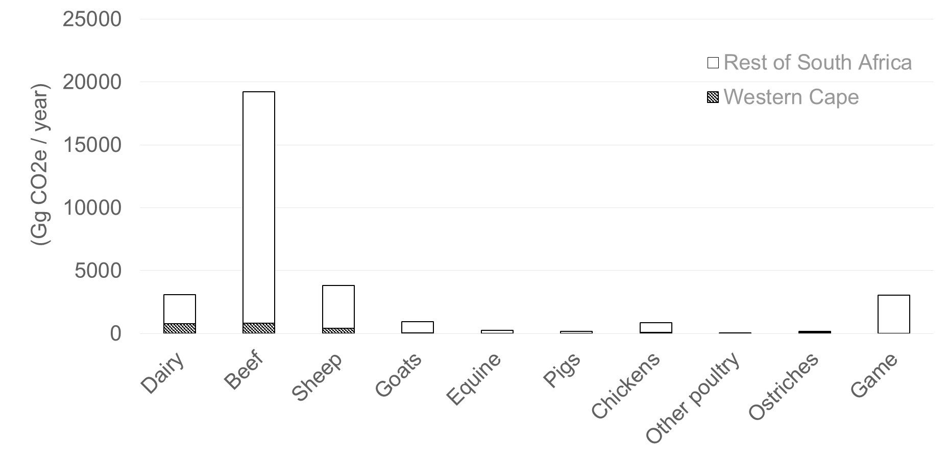
Figure 10: Direct GHG emissions from livestock in South Africa

From focus areas to GHG reduction interventions
From the different sectors considered in detail, a number of areas of intervention were identified. Some of these have been prioritised by GreenCape, hence work is being done to encourage uptake of alternative and more sustainable practices in these key areas. A number of these interventions are highlighted here, namely:
- Solar heating for agri-processing
- Solar photovoltaic (PV) on packhouses
- Solar pumps and variable speed drives for irrigation
- Biogas from agricultural wastes and residues, and in particular manure
For each of these, the focus is on presenting the business case to encourage uptake in the agriculture and agri-processing sectors. The work thus highlights that environmental and economic objectives can be complementary.

General drivers
As most of the options identified align with sustainable energy use, the increasing energy prices act as a strong driver for greater uptake of alternative energy sources. The rising electricity prices have been especially noteworthy, increasing by over 400% in the last decade, clearly outpacing the rise in average prices as shown in Figure 11. Increasingly energy costs are expected to be a significant cost driver and alternative energy sources are thus more likely to be financially viable.
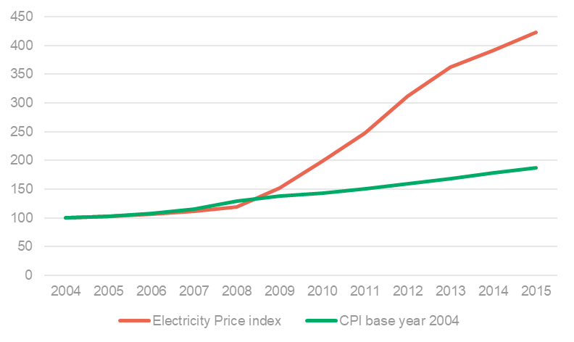
Figure 11: Electricity price index and consumer price index (2004 base year)

In addition to the rising electricity costs, one of the great advantages of the renewable energy sources, especially solar have no fuel costs and avoid the volatility of oil based energy sources.
Additionally, as many of South Africa’s high value markets for food are international with customers increasingly demanding lower carbon products, all the areas identified provide an opportunity to gain a market edge in these high value markets. Lower carbon production is also set to be incentivised with South Africa’s carbon tax that are expected to tax carbon emissions at R120 per tonne of CO₂e of GHG emissions that are released. However, the carbon tax, initially proposed in 2013, has yet to be instituted.

Solar heat for agri-processing
South Africa has some of the highest solar irradiance in the world, showing great potential for solar energy as a heating source (Joubert & Van Niekerk, 2015, p. 112). Agri-processing generally requires significant shares of heat, with 79% of final energy needs in the sector being for heat (Lampreia, 2014). Additionally, the processing sector was highlighted as a key GHG emission source when considering wine in Section 2.2.1. Thus a key area to reduce the GHG emissions within agri-processing generally, and wine specifically, is increased uptake of solar heating systems for process heating needs. The potential within South Africa’s agri-processing sector is estimated at 425 000 – 3758 000 m² of collectors or providing 425 – 3 758 GWh of thermal energy per annum, within South Africa’s agri-processing sector representing a potential carbon saving of 111 000 – 943 000 t CO₂e per annum (Janse van Vuuren & Jezile, 2017; Janse van Vuuren, et al., Forthcoming 2017).
Joubert, Hess & van Niekerk (2016) have shown that the application of solar thermal energy to replace conventional energy sources is financially viable for most energy sources as shown in Figure 12 and Figure 13. It is important to note that these figures contain error bands showing best and worst case scenarios for each of the fuels considered, thus while the payback period for electricity (Figure 13) is on average 10 years with no increase in electricity price, in some instances it would pay back in less than 5 years. When considering both Figure 12 and Figure 13, it becomes evident that supplementing energy needs with solar thermal is worth considering for all energy sources except perhaps for coal, although if the proposed carbon tax is instituted this too could change. Given the fact that solar thermal systems are expected to have a lifetime of approximately 20 years, this would mean that solar thermal systems would on average provide 7 ½ years of ‘free’ energy when replacing heavy fuel oil (HFO) if there is no increase in HFO prices. Similarly, the internal rate of return (IRR) (Figure 12) when supplementing systems with solar thermal show that when replacing diesel with solar thermal an average IRR of 18% is achieved if diesel prices remain unchanged i.e. the investment earns an average of 18% return.
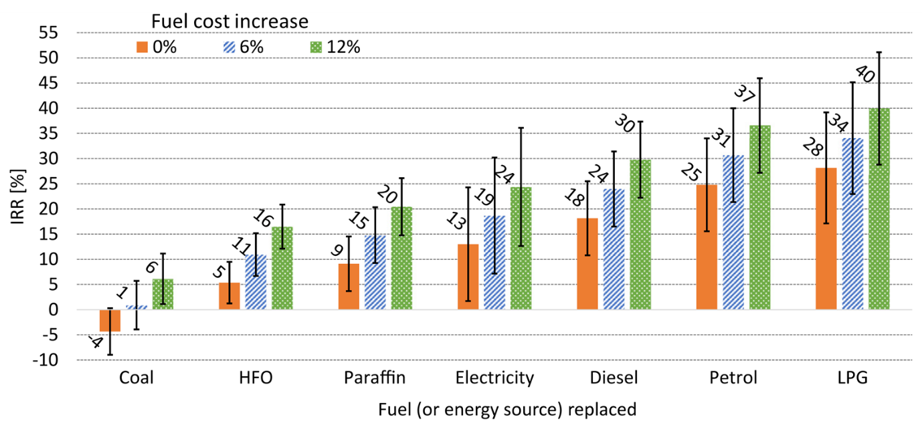
Figure 12: Internal rate of return (IRR) for a current large-scale system with a service life of 20 years replacing different conventional fuels
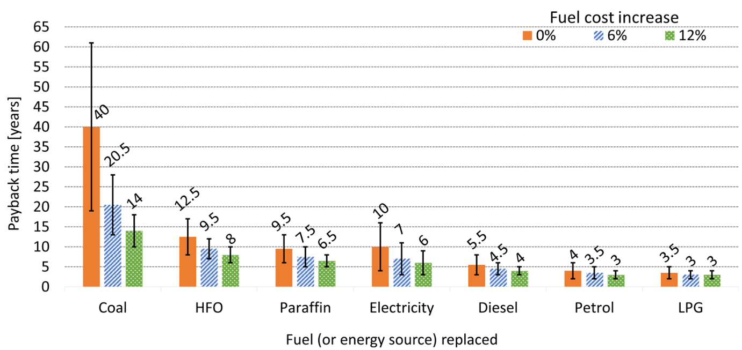
Figure 13: Payback periods of current large-scale solar thermal system when substituting conventional energy sources¹²

Barriers
Traditionally, solar heating in South Africa has focussed at the residential scale driven by government programmes. There are strong legislative barriers, with the lack of component testing of systems a key barrier to greater development of the solar heating market, as expounded in Hertzog (2012). This greatly limits the local competition and consequently production of solar heating systems, as local accreditation is only possible for whole systems and not individual components, as has become the norm internationally.
Solar thermal systems in South Africa are still relatively expensive when compared with solar thermal systems internationally, indicative of an infant industry that requires government support to ensure that the industry becomes cost competitive. This is further supported by the large variance in proposals received for the same project as shown in Joubert et al. (2016). In addition, solar thermal systems are perceived to be untested and unreliable in spite of numerous installations internationally and several locally (Epp & Oropeza, 2017; SOLTRAIN, 2016). The lack of general consensus is reflected by financial institutions not being willing to finance solar thermal systems that in turn increases the financing costs of solar thermal that is partially driven by the long term characteristics of solar thermal systems.

Drivers
Solar heating uptake is supported by a number of local entities, with one of the most prominent being Southern African Solar Thermal Training and Demonstration Initiative (SOLTRAIN), which aims to encourage sustainable energy uptake with a focus on solar thermal applications in Southern Africa region. SOLTRAIN provides training in solar thermal, training over 1200 people already. In addition SOLTRAIN support demonstration systems as case studies for the use of solar thermal energy including one of the first industrial scale solar thermal systems at Cape Brewing Company (SOLTRAIN, 2016). Additional support is also available through SANEDI and the German Chamber of Commerce through their Solar Payback Project that aims to support the uptake of industrial scale solar heating (Epp & Oropeza, 2017). In addition, large scale installations could benefit from government income tax incentives; section 12i and 12l tax rebates.
Given the strong business case and poor perceptions, there is a clear role for knowledge dissemination of this opportunity to help increase the uptake of this opportunity.

Solar PV on packhouses
A business case has been prepared for solar PV on packhouses to highlight the opportunity that solar PV presents for packhouse owners (Janse van Vuuren, 2016). This is due to its energy generation profile aligning well with packhouse energy consumption, which is generally a constraint for renewable energy solutions in other (industrial) applications (Janse van Vuuren, 2016). The linking of solar PV to cooling needs has the additional advantage of the solar PV system already absorbing a substantial amount of the heat before it heats the building (insulation effect), and thus reduces the energy needed to cool before even providing any electricity. The business case report models an apple packhouse for a year based on ‘typical’ energy needs of the different packing components. This allows an energy profile to be drawn up, as shown below, highlighting the seasonality of a packhouse and the accompanying energy supply and demand.
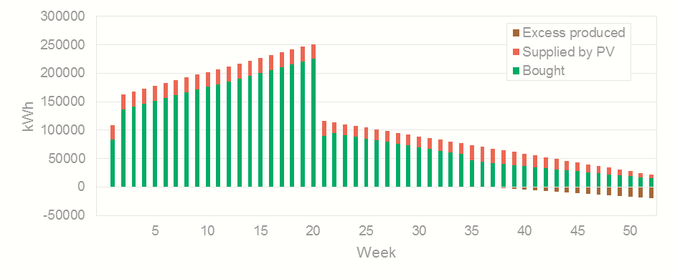Figure 14: Electricity profile of a packhouse packing 1000 tonnes of apples a week with a 500 kW_{p} solar PV system installed.

The business case considers a number of scenarios, including different sizes of solar PV installations, electricity tariffs, future electricity prices and loan terms. From this range of scenarios, the results highlight three key learnings:
- Tariffs and regulations are key: it is not possible to connect to and feed-in to the grid everywhere, most notably for low voltage connections. This is a key limitation on greater uptake of solar PV.
- The economies of scale are significant: large (500kW_{p}) systems were feasible in all scenarios considered. The business case indicated 8 – 13 years of ‘free energy’ once the system is paid off based on simple payback or a net present value in the range of R0.5-R4.1 million for the R8.1 million modelled system. The internal rate of return was also greater than 18% in all scenarios.
- Financing is key to unlocking the full potential of solar PV: even small systems (≤10 kWp) are financially viable under the right financing conditions. Small systems in the model achieved 5 – 10 years of ‘free energy’ once the system is paid off based on a simple payback period. However, positive net present value is achieved only under favourable (10%) loan terms.
- A number of packhouses have already been able to profitably install solar PV, showing the applicability of this technology to this application with approximately 6MW_{p} already installed in the fruit and wine sector (Wagner, 2016, p. 38).

Barriers
The long term nature of solar PV installations makes the financing thereof problematic as risks increase the longer term the investment. The rural location of many packhouses has also limited uptake as theft is of significant concern with risks of theft so high that insurance no longer covers farms. The regulatory environment also limits uptake of solar PV as it is not legal to connect solar PV to the grid everywhere in South Africa. However, there are currently 15 Western Cape municipalities that allow solar PV.

Drivers
The solar PV business case is increasingly well understood by financiers with longer term financing being made available for solar thermal (though still short of solar PV’s lifetime). New, innovative contracting has also helped unlock further installations through an energy service company (ESCO) model which take two main forms. In the first form, the ESCO guarantees savings to energy using company with excess savings going to the ESCO. The second ESCO contract works on the ESCO selling energy to the energy using company at a lower rate than they would have paid for their original energy provider. SANEDI has launched an ESCO register to help facilitate the uptake of renewable energy.
To ensure that there are accredited installers for solar PV, a test for service technicians has been developed by South African Renewable Energy Technology Centre (SARETEC) who train installers to support the local market. The South African Photovoltaic Industry Association (SAPVIA) has recently released the industry PV GreenCard, an industry led quality label to provide potential customers quality assurance as it ensures that installers are qualified with proven experience in installing solar PV.
Given the rising electricity costs and increasing ease of vetting installers, solar PV installations are likely to continue increasing especially in cases where energy demand match PV generation such as cooling needs which has been demonstrated to be the case for packhouses.

Solar pumps and variable speed drives for irrigation
As highlighted by the wheat LCAs, GHG emissions associated with irrigated grain production is linked to irrigation pumping. More efficient or low carbon pumping systems, including variable speed drives and solar pumps, can be expected to significant decrease the carbon emissions of the sector. The impact of variable speed drives on decreasing energy use of pumps has already been shown with a case study on Achtertuin Farm in Ceres. The success was showcased by Confronting Climate Change (2014f), highlighting:
- Expected payback of 2 to 3 years
- 34% reduction in pump energy use
In addition to increasing the effectiveness of pumping, another alternative is to use a more sustainable energy source such as solar energy. In an electricity consumption breakdown of on-farm activities for irrigation farms, electricity used for irrigation pumping is by far the largest consumer. On an average fruit and vegetable farm, 62% of electricity use is for irrigation pumping (Kuschke & Geyer, 2016, p. 28). As a result, solar pumps have been highlighted as an opportunity in GreenCape’s latest agricultural market intelligence report, which provides information on available technology providers and stakeholders (Kushke & Jordaan, 2017).

Biogas
The biogas process is depicted in Figure 15 below. A variety of possible feedstocks can be diverted to an anaerobic digester (AD), which breaks down the organic material in an oxygen-scarce environment to produce biogas, a mixture composed primarily of methane (≈55%) and carbon dioxide (≈45%). The process also produces two by-products, namely: liquid and solid digestate.
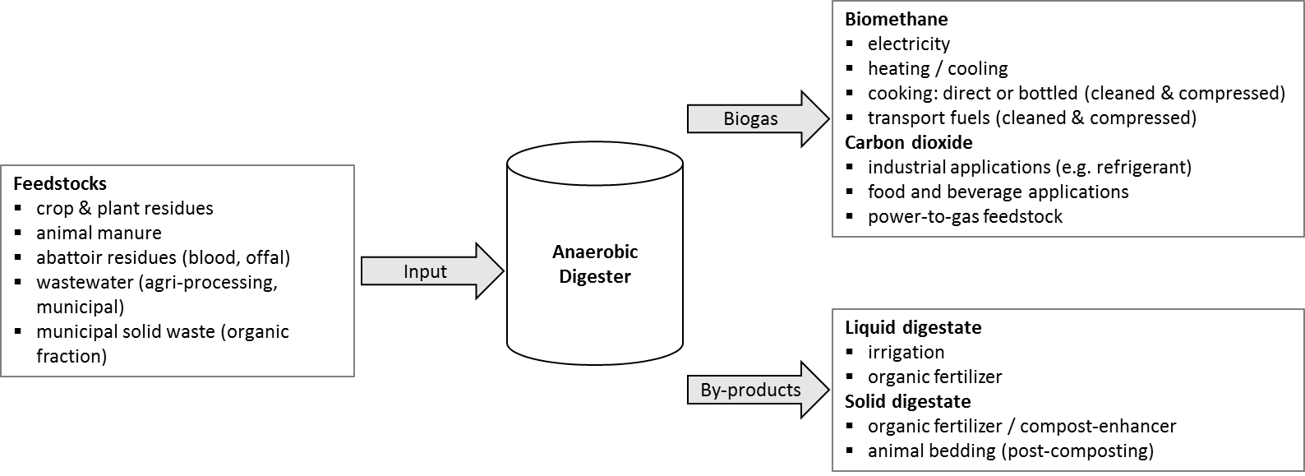
Figure 15: Schematic of the anaerobic digestion process

Each stage of the anaerobic digestion (material input, gas production and storage, and product utilisation) may have impacts in terms of GHG emissions. For example when considering the material inputs, the residues used as feedstocks generally result in methane emissions when landfilled or disposed of on-field; this is mitigated when biogas is implemented. Furthermore, the use of anaerobic digestion products can help offset GHG emissions elsewhere. For instance, through the substitution of fossil-based fuels with biomethane; or the reduction in the use of synthetic fertilizers, the production of which is associated with significant GHG emissions. Examples of each were highlighted in phase two of the project and are considered in turn below.
The clearest opportunity is the use of biogas to replace South Africa’s carbon intense electricity, which has been highlighted as problematic in the fruit and wine sector. There are however a number of uses for biogas. This includes transport fuel, which was shown as significant in the grain sector (fuel combustion), and the transport sector more broadly, which is a significant and relatively intense GHG emitting sector, as indicated in Figure 2 and highlighted more clearly in Janse van Vuuren (2015a). Additionally, the use of heat generated from biogas (either from combustion, or use of exhaust heat from engines) can help offset GHG emissions arising from the use fossil-based fuels in the industrial or agro-processing sectors.
Some of the key feedstocks highlighted for biogas production include various agricultural residues. Manure was particularly shown to be significant share of intensive livestock’s direct GHG emissions (e.g. in feedlots) and thus harvesting the methane through an anaerobic digester is a potential intervention to reduce GHG emissions and the carbon intensity of the sector, especially noting that methane has a GHG potential over 20 times (typically indicated as 21 – 25 times) greater than carbon dioxide.
In addition to reducing GHG emissions, the production of biogas simultaneously adds value to the farm. The value addition of biogas is two-fold: firstly, through the production of biomethane, a renewable energy source. Secondly, through both digestates (solid and liquid) that can be used as fertiliser or, as demonstrated in the Western Cape for solid digestate, as bedding for dairy cattle after composting. Given the significant contribution that fertiliser production has on the GHG emissions of grain (as indicated in Section 2.2.3), replacing fertiliser with digestate may have a significant impact on GHG emissions. In addition, there is increased use of the carbon dioxide by-product in applications such as refrigeration, food and beverages, and water treatment.

Business case for biogas
To facilitate the uptake of this GHG emission-reducing opportunity, a business case has been developed to inform potential investors of when biogas makes business sense. The socio-economic potential of biogas in the Western Cape has also been assessed, considering potential market investment, job creation, landfill diversion, and energy generation.
Preliminary findings suggest that the animal husbandry sector (abattoirs, dairy, piggeries) as well as organic-rich wastewaters from food processing are key areas to target for investment in biogas in the Western Cape. The potential market size of the industry in the Western Cape is conservatively estimated at R4 billion, with job creation conservatively estimated at 320 direct jobs at a labour intensity of 4 – 10 direct jobs/MW_{e} (GreenCape, forthcoming), with total potential electricity production estimated at 87 – 395 MW_{e} (Agricultural Research Council, 2016; GreenCape, forthcoming).

Factors influencing the financial viability of biogas projects in the Western Cape:
- The cost of organic waste disposal
  - Waste management concerns are generally the primary driver for biogas uptake in the Western Cape. Legislative pressures such as landfill bans and provincial government waste diversion targets, are increasing the cost of organic waste disposal at landfills and thus increasing the viability of alternative waste management processes.
- Feedstock procurement and logistics.
  - Securing a long-term feedstock supply with minimal logistics/transport requirements.
- The potential for combined heat and power. This is vital to financial viability and can take various forms, specifically:
  - Use of the energy on-site (both heat and power)
  - Securing a private power purchase agreement (PPA), either through electricity wheeling via the grid, use of heat at an adjacent site, or gas compression and bottling. It is standard procedure to secure a long-term offtake agreement in order to reduce project risk.
- The management of the digestate by-product:
  - Having a digestate buyer or own-use such as irrigation/fertilizer improves the business case.

Key barriers influencing uptake of biogas projects in the Western Cape:
- Licensing procedures, specifically the time required for licence approval, legal costs associated with licencing and lack of stakeholder understanding with respect to the associated procedures.
- Lack of stakeholder awareness: many businesses interested in making better use of their waste are often cautious of biogas, generally due to unfamiliarity with the technology. As such, many stakeholders opt for a more familiar and recognised solution such as composting.
- High relative capital costs: biogas is generally associated with higher capital costs than other waste management techniques such as composting.
- The lack of clarity with regard to power purchase agreements and electricity grid feeding (especially for small scale embedded generation).
- Lack of existing gas infrastructure: South Africa has very limited natural gas pipeline infrastructure, thus greatly inhibiting the potential for feeding gas into the grid.
- Economies of scale: many agri-processing operations do not have the necessary economies of scale to make biogas economically feasible. Furthermore, agri-processing activities are often rural and widely dispersed, decreasing the viability of centralised solutions.
- Lack of local operational skills: as biogas is a nascent industry in South Africa, process knowledge and operational skills are rare and highly sought after. As such, finding necessary operational skills is often difficult and costly, with many project developers resorting to contracting labour from countries with highly-developed biogas industries, such as Germany.
Biogas holds potential for low carbon, labour absorptive economic development in the Western Cape. Increased uptake of the technology will lead to capital investment, job creation, improved waste management, and cleaner energy production. The economic feasibility of biogas installations and changing waste regulatory environment are becoming more conducive to the growth of this sector. However, there are still significant barriers and challenges that must be addressed to increase uptake of the technology, and hence realise its full potential contribution to low-carbon economic development.

Conclusion
The paper has shown that it is possible to develop targeted GHG reduction interventions by working from a very broad economic level down to key GHG emission focus areas and finally targeted interventions. Communicating these interventions to industry as business cases highlights that GHG emissions challenges can be addressed in a manner that both decreases GHG emission and, makes business sense. This is done by focussing on the business cases for these solutions presenting them, not in the light of how they are advantageous to the environment, but rather how they can positively impact the bottom line of businesses in these sectors to encourage uptake.
One of the key insights from the work done at GreenCape is the value of systems thinking to enable long-term sustainability. To enable the focus areas to be well thought out, it is key to consider the full value chain or ‘life cycle’ of products. At a macro-level, the Social Accounting Matrix (SAM) can help inform this, as it implicitly considers the value chains of sectors. However, to consider issues such as GHG emissions, researchers require more information than is currently reported in SAMs, and even when considering alternative sources to supplement the SAM, an extension considering water was deemed unfeasible at present due to data availability. This highlights the need for information to inform life cycle based analysis, with this need demonstrated for all the agricultural sub-sectors considered: only the grain sub-sector analysis could be undertaken as an actual life cycle assessment using local farming data (as opposed to a meta-analysis of the results other local and international studies).
The value of the considering the entire system, or whole value chain, is also highlighted clearly in the case for biogas with insights from a number of sub-sectors’ hotspots being addressed (i.e. high GHG intensity of electricity and fertilisers, as well as manure management). When simply considering biogas as an energy source it is unable to compete with other renewable energy sources such as solar PV and wind on a cost per kWh basis. This is shown by its relative high cost (R1.40 per kWh) in the Renewable Energy Independent Power Producers Procurement Programme (GreenCape, 2014, p. 8). However, when considered as a waste beneficiation technology that both decreases two key GHG emissions sources (animal manure and the use of GHG emission-intense chemical fertilisers) while simultaneously increasing energy security, the strategic advantage in facilitating biogas uptake is clear. This also shows the need for continued strategic analysis to ensure that similar strategic opportunities can be pursued that might not seem to be viable under a narrow scope and evaluated based on a single (price) consideration.
As a whole, this paper has highlighted both methodological and practical approaches that can support mitigation of carbon emissions (and other environmental) impacts in the food value chain. It has shown that the embedding of systems thinking is critical to support farmers and agri-processors experiencing the pressure for climate mitigation actions to select strategies and interventions with overall long term gains, and not merely short term gains or gains that do not have a net benefit. Presenting carbon mitigation interventions as business cases, rather than arguing the case on an environmental basis, is also expected to enable more rapid uptake of effective GHG mitigation interventions.

References
Agricultural Research Council, 2016. Estimating the Biogas Potential for Electricity Generation from the Agro-Waste Industry, Pretoria, South Africa: Deutsche Gesellschaft für Internationale Zusammenarbeit (GIZ) GmbH.
Cerutti, A. K. et al., 2015. Life Cycle Assessment in the Fruit Sector. In: B. Notarnicola, et al. eds. Life Cycle Assessment in the Agri-food Sector: Case Studies. Methodological Issues and Best Practices. New York: Springer International Publishing, pp. 333-388.
Confronting Climate Change, 2014a. Wine Industry Report - Year 2: 2013 Carbon Footprint Results. [Online]
Available at: http://www.climatefruitandwine.co.za/Documents/CCC_Wine%20Industry%20Report_2013.pdf
[Accessed 9 December 2014].
Confronting Climate Change, 2014b. Stone fruit Industry Report - Year 2: 2013 Carbon footprint benchmark report. [Online]
Available at: http://www.climatefruitandwine.co.za/Documents/CCC_Stone%20fruit%20Industry%20Report_2013.pdf
[Accessed February 25 2015].
Confronting Climate Change, 2014c. Table Grape Industry Report - Year 2: 2013 Carbon footprint benchmark report. [Online]
Available at: http://www.climatefruitandwine.co.za/Documents/CCC_Table%20Grape%20Industry%20Report_2013.pdf
[Accessed 25 February 2015].
Confronting Climate Change, 2014e. Industry Level Trends report: Year 2 - 2013 Carbon footprint results for the CCC South African fruit and wine sample group. [Online]
Available at: http://www.climatefruitandwine.co.za/Documents/CCC_Industry%20Level%20Trends%20Report_2013.pdf
[Accessed 25 February 2015].
Confronting Climate Change, 2014f. Pome fruit Industry Report - Year 2: 2013 Carbon footprint benchmark report. [Online]
Available at: http://www.climatefruitandwine.co.za/Documents/CCC_Pome%20fruit%20Industry%20Report_2013.pdf
[Accessed 25 February 2015].
CROPWAT, 2015. version 8.0. [Online]
Available at: http://www.fao.org/nr/water/infores_databases_cropwat.html
DEADP, 2013. Energy Consumption and CO2 Emmisions Database for the Western Cape. [Online]
Available at: http://eadp.westerncape.gov.za/content/western-cape-energy-consumption-and-co2e-emissions-database-reports-2012
[Accessed 13 November 2013].
Development Bank of Southern Africa, 2008. Social Accounting Matrices (SAMs). [Online]
Available at: http://www.dbsa.org/EN/DBSA-Operations/Proj/Tools/Pages/SAMS.aspx
[Accessed 26 June 2014].
Energy Research Centre, 2013. SATIM Methodology v2.1. [Online]
Available at: http://www.erc.uct.ac.za/Research/esystems-group-satim.htm
[Accessed 19 August 2014].
Eora MRIO Database, 2014. South Africa Satellite Indicators. [Online]
Available at: http://worldmrio.com/
[Accessed 16 October 2014].
Epp, B. & Oropeza, M., 2017. Solar Heat for Industry, s.l.: German Solar Association BSW-Solar.
GreenCape, 2014. Market Intelligence Report: Renewable Energy 2014, Cape Town: GreenCape.
GreenCape, forthcoming. The business case for biogas, Cape Town, South Africa: GreenCape.
Hertzog, H., 2012. A Technical Motivation for: Component Testing for Solar Water Heating. [Online]
Available at: http://greencape.co.za/assets/Uploads/energy-efficiency/Component-testing-for-SWH-120912-1.pdf
[Accessed 8 February 2016].
Janse van Vuuren, P., 2016. The business case for solar PV on packhouses, Cape Town: GreenCape.
Janse van Vuuren, P. F., 2015a. Regional Resource Flow Project – Social Accounting Matrix Analysis, Cape Town: GreenCape.
Janse van Vuuren, P. F., 2015b. Wine Industry Analysis Using Life Cycle Thinking, Cape Town: GreenCape.
Janse van Vuuren, P. F., 2015c. RRFM - Fruit sector report, 2015: GreenCape.
Janse van Vuuren, P. F. et al., Forthcoming 2017. Industrial scale solar heat in South Africa: Opportunities in agri-processing and textiles, Cape Town: World Wildlife Fund.
Janse van Vuuren, P. F. & Jezile, A. A., 2017. Business case for solar heating in agriprocessing. Renewable Energy Focus. ESI-Africa, pp. 10-12.
Joubert, E., Hess, S. & Niekerk, J. V., 2016. Large-scale solar water heating in South Africa: Status, barriers and recommendations. Renewable Energy, Issue 97, pp. 809-822.
Joubert, E. & Van Niekerk, J., 2015. Industrial Solar Process Heat Yield and Feasibility. Third Southern African Solar Energy Conference, Volume 3, pp. 112-117.
Kuschke, I. & Geyer, J., 2016. Agriculture: 2016 Market Intelligence Report, Cape Town: GreenCape.
Kushke, I. & Jordaan, J., 2017. Agriculture: 2017 Market Intelligence Report. [Online]
Available at: http://www.greencape.co.za/assets/Uploads/GreenCape-Agri-MIR-2017-electronic-FINAL-v1.pdf
[Accessed 30 May 2017].
Lampreia, J., 2014. Industrial renewable heat. [Online]
Available at: https://www.carbontrust.com/news/2014/05/industrial-renewable-heat/
[Accessed 3 February 2016].
Pineo, C., 2015a. Regional Resource Flow Model: Grain Sector Report, Cape Town: GreenCape.
Pineo, C., 2015b. Regional Resource Flow Model: Livestock and Game Sector Report, Cape Town: GreenCape.
Pineo, C., Janse van Vuuren, P., Basson, L. & Petrie, J., 2015. Regional Resource Flow Model Project 2014/2015: Synthesis Report, available on request: GreenCape: Report to Funder.
Rugani, B., Vázquez-Rowe, I., Benedetto, G. & Benetto, E., 2013. A comprehensive review of carbon footprint analysis as an extended environmental indicator in the wine sector. Journal of Cleaner Production, Volume 54, pp. 61-77.
SAWIS, 2014. South African Wine Industry Statistics. Issue 38.
SOLTRAIN, 2016. SOLTRAIN - Southern African Solar Thermal Training & Demonstration Initiative. [Online]
Available at: http://soltrain.co.za/
[Accessed 29 May 2017].
Steinfeld, H. et al., 2006. Livestock's long shadow: environmental issues and options. [Online]
Available at: ftp://ftp.fao.org/docrep/fao/010/A0701E/A0701E00.pdf
[Accessed 20 February 2014].
van Niekerk, P., 2014. Level Playing Fields? The International Wine Market. Wineland, Volume November, p. 80.
Wagner, N., 2016. (Solar) Light at the end of the tunnel?. Agriprobe, 13(2), pp. 38-39.
Western Cape Government Provincial Treasury, 2013. Provincial Economic Review & Outlook 2012 (PERO). Cape Town: s.n.

TIPS is a research organisation that facilitates policy development and
dialogue across three focus areas: trade and industrial policy; inequality and
economic inclusion; and sustainable growth. The Annual Forum is platform for researchers, policymakers and other stakeholders to present research and engage in dialogue on
policy-relevant issues. The Forums have overarching themes and have been running since 1997.
For details of past Forums and copies of research presented go to Forum Papers
info@tips.org.za +27 12 433 9340 www.tips.org.za
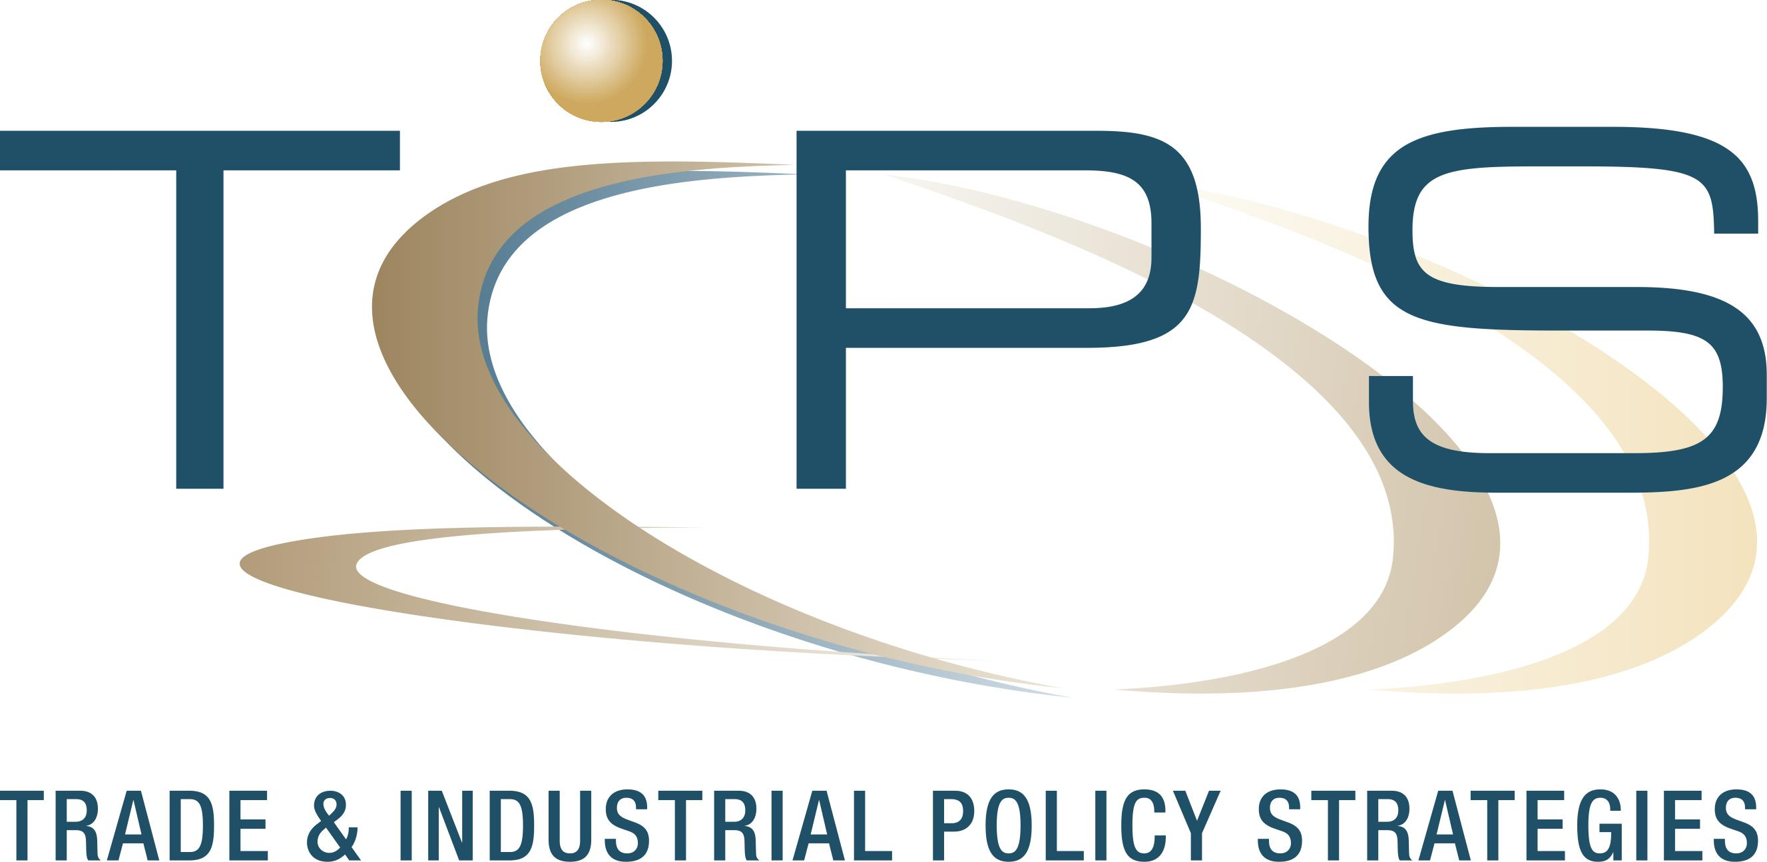

For more TIPS Policy Briefs go to www.tips.org.za

info@tips.org.za
+27 12 433 9340
www.tips.org.za

South African TIMES* model (Energy Research Centre, 2013), Eora Multi-Regional Input-Output database (Eora MRIO Database, 2014) and Provincial energy and emissions report (DEADP, 2013). *The Integrated MARKAL-EFOM System
Including a water extension to the SAM was considered as well, but a lack of sufficient consistent data prevented further analysis
Own calculations based on social accounting matrices output totals (Development Bank of Southern Africa, 2008).
The CO₂e emissions related to the production of a product. The Confronting Climate Change (CCC) carbon footprinting tool utilising the Publicly Available Specification (PAS) 2050 as methodological guideline.
Adjusted from Janse van Vuuren (2015b, p. 6) .
However, this may be due to a sampling bias as more carbon sensitive farmers are more likely to have made use of Confronting Climate Change’s (CCC) carbon footprinting tool.
Adjusted from Janse van Vuuren (2015c, p. 4)
Adjusted from Janse van Vuuren (2015c, p. 7)
Minimum tillage practices involve minimum disturbance of soil and the maintenance of soil top cover. Conventional tillage practices were also considered in the study and are labelled as “Conventional 1 and Conventional 2” in Figure 8. For more detail on the study and the budgets see Pineo (Pineo, 2015a).
Adjusted from Pineo (2015b, p. 9).
Own calculations using NERSA approved average tariff adjustment as per published tariff book indexed to base year 2004 (Eskom, 2016) and historical Consumer Price Index (CPI) (StatsSA, 2016)
Source: Joubert, et al. (2016, p. 820) for a system that costs 603 EUR/m²
See: http://www.greencape.co.za/content/small-scale-embedded-generation-in-the-western-cape/ for updates.
Available at: sanediesco.org.za.
Available at: https://www.pvgreencard.co.za/
typically coal, heavy/light fuel oils and diesel.
which is captured and utilised in the anaerobic digestion process, rather than released into the atmosphere
With employee skills ranging from low-skilled (e.g. feeders) to highly-skilled (process engineers, biochemists)
Megawatt electrical
For specific types of waste
Generally, 10-20 years

