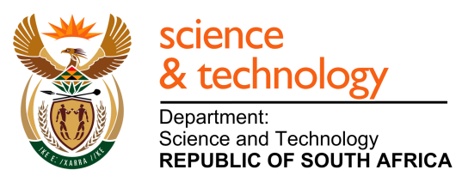 | 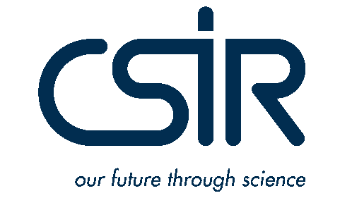

2015 Call for Proposals

Research, development and innovation (RDI) to advance the
South African waste sector

Announcement

Call for proposals

The Department of Science and Technology (DST) is pleased to announce a Call for Proposals for (solid) waste research, development and innovation projects commencing in 2016. Applicants are requested to familiarise themselves with the information provided in this Call as well as in the Waste Research, Development and Innovation (RDI) Roadmap for South Africa (2015-2025), before preparing an application.

- Strategic framework of the Waste RDI Roadmap (6 Clusters) – available online at:
http://wasteroadmap.co.za/download/rdi_clusters.pdf

- Waste RDI Roadmap – available online at:
http://wasteroadmap.co.za/download/waste_rdi_roadmap_summary.pdf

Background

The Waste RDI Roadmap is an initiative of the DST, managed by the CSIR, aimed at strengthening –
- human capital development (HCD)
- research and development (R&D), and
- innovation in the field of solid waste management

Through the strategic investment in science, engineering and technology, the Department aims to support the prevention of waste and the optimised extraction of value from waste reuse, recycling and recovery, in order to create significant social, economic, and environmental benefit for the country.

The Waste RDI Roadmap provides a framework to implement –
- More effective decision-making
- Faster insertion of context-appropriate technology
- Export of know-how and technology
- Strengthened RDI capability and capacity

Research themes

Research proposals must be aligned with one of the following thematic areas and sub-themes of the Waste RDI Roadmap –

- Technology Solutions
Design, development, evaluation, demonstration, localisation and deployment of technologies (both local and inbound) for customer-driven performance improvement
- Process Performance Optimisation
- Technology Development
- Technology Evaluation and Demonstration
- Technology Localisation

- Modelling and analytics
Develop and use methods, tools, techniques, platforms, systems and frameworks for the analysis, monitoring and evaluation of technical, economic, social and environmental opportunities and impacts associated with secondary resources
- Systems Analysis and Modelling
- Business Models
- Socio-Economic and Environmental Modelling
- Analytics
- Impact Assessment

- Waste logistics performance
Optimisation of strategic, tactical and operational decision-making in respect of logistics objectives, assets and resources
- Strategic Network Design
- Planning and Management Systems
- Operational Logistics Processes

- Strategic planning
Build and strengthen the basis and application of strategic analysis and advice for the purposes of evidence-based decision-making to inform strategy formulation, planning and its execution and management
- Macro-Economics
- Value Chain
- Strategy
- Policy and Legislation
- Governance

- Waste and environment
Strengthen the ability to identify, monitor, evaluate and report on environmental impacts of waste and its management, in order to inform better targeted and more effective responses
- Climate change

- Waste and society
Deepen understanding of waste-related opportunities and threats, to increase the success of influencing perception and practice positively
- Jobs and Labour
- Business Practices
- Behaviour
- Awareness and Communication
Proposals must also address one of the following priority waste streams –
- Organic waste
- Plastic waste
- Electronic waste (WEEE)
- Municipal waste

R&D and Innovation in waste tyres, while a priority of the Waste RDI Roadmap, will continue to be supported by REDISA and is therefore not a focus of this Call for Proposals.

Eligibility criteria

Researchers from South African Universities, Science Councils and other public research institutions, working in relevant disciplines, are invited to submit proposals for the DST/CSIR research grants.

Evaluation criteria

All applications will undergo evaluation by an independent review panel, to assess the suitability of the proposal in terms of the Waste RDI Roadmap’s objectives. All proposals will be evaluated against the following criteria:

- Alignment: the research proposal must address the priorities and research themes of the Waste RDI Roadmap (Section 3 above)
- Relevance: the research must have the potential to directly, and positively, influence the management of solid waste in South Africa, by moving waste up the hierarchy away from landfilling towards waste prevention, reuse, recycling or recovery, in a manner that will provide maximum environmental, social and economic benefit for the country
- Scientific/technical soundness and credibility: the research proposal has a sound scientific and/or technical base, reflects a sound grasp of the issues requiring investigation, the proposed methodologies are appropriate for achieving the objectives; and the deliverables and associated time frames for delivery are realistic.
- Innovation: the project is original and contributes to the body of knowledge or develops practical solutions to move waste away from landfilling towards waste prevention, reuse, recycling or recovery
- Research Outputs/Deliverables: the project must result in a significant research output, such as research reports, technologies, journal papers, qualifications
- Capacity development: Only projects that include an element of capacity development through the training of post-graduate students, interns or junior staff will be considered
- Institutional capacity: the applicant should demonstrate sufficient institutional capacity to implement the project
- Value for money: the benefits of the proposed research are measurable and the value of the benefits exceed the value of the investment

Equity and redress

In line with the national imperative of equity and redress, the research call prioritises support for designated groups viz. black, female and persons with disabilities.

Submission of proposals

To be eligible for consideration, proposals must be submitted on the research proposal template provided, and submitted in .pdf format. Research proposals (Part III: Detailed description of the project) should not exceed 10 pages and should include the following:
- Title of project:
- Abstract (max 250 words)
- Keywords (max 5 words)
- Outline of the research project
  - Statement of Research Problem
  - Background and Rationale
  - Literature Review
  - Research Question/s
  - Aims and Objectives of the Research
  - Research Design and Methodology
- Significance of the Research
- Expected Outcomes, Results and Contributions of the Research
- Workplan
- References cited
- Brief CV of Lead Researcher and core team members with allocated contribution to project

Reservations

The DST expressly reserves the following rights:
- To reject all or any proposals
- To waive any or all irregularities in the proposals submitted
- To retain the right not to select any application/s even if meeting all the requirements

Contract negotiations

The successful applicant/s will be required to enter into a written Agreement with the CSIR, who manages the Roadmap on behalf of the DST.

Validity

All applications will be regarded as valid for 180 days from the 9 December 2015 whereafter the CSIR may request an updated application, should this become necessary.

Closing date

Applications must be submitted electronically via email to info@wasteroadmap.co.za in the prescribed format. The deadline for the submission of proposals is Wednesday, 9 December 2015 at 17:00.

All applicants will be notified about the outcome of their applications before the end of January 2016.

For any queries relating to the call for proposals, contact:

Prof Linda Godfrey
Manager: Waste RDI Roadmap Implementation Unit
Telephone: 012 841 4801
Fax: 012 842 7687
E-mail: LGodfrey@csir.co.za

